**Curry’s Home Page**

The changes I made for curry’s Home page

**Currys Current Home Page**

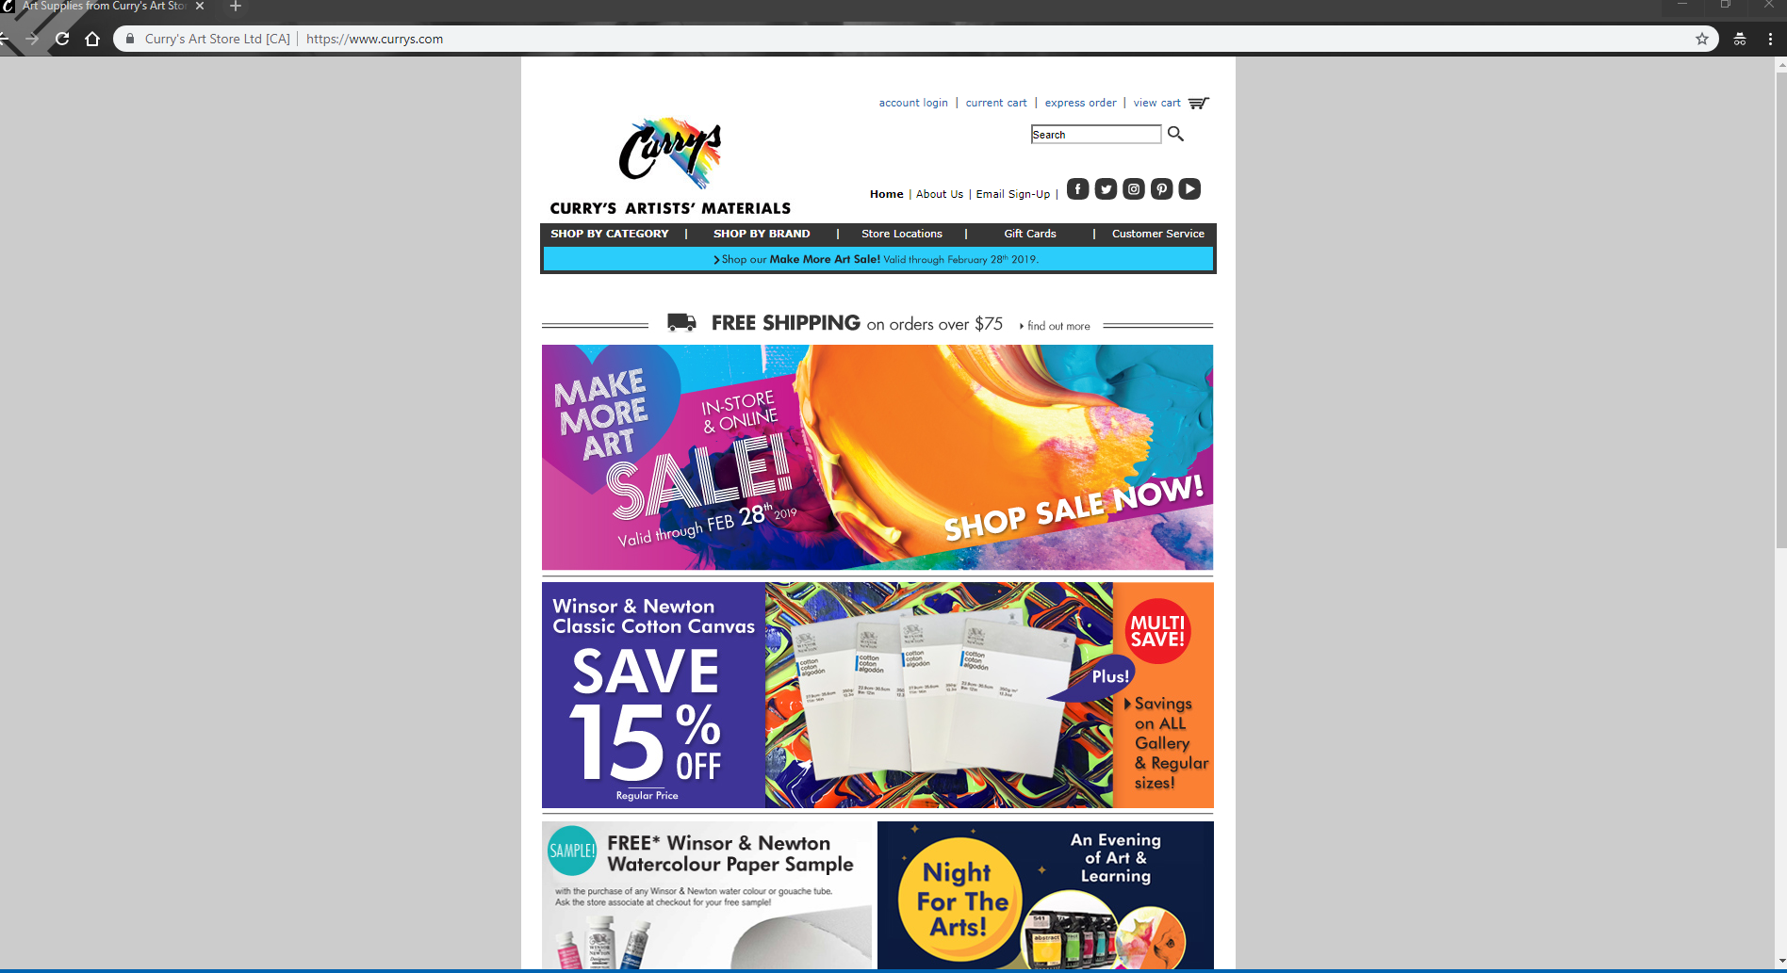

**Changes I made**

1. I changed the design for the main page mainly because things look really cramped and needed to be re shuffled
2. Made the Sales more orgonized as well as the in store loyalty program because I felt those were the most important parts
3. Changed the Navigation bar a bit to take out some unnecasary items, like Gift Cards and added Customer Service in the navigation bar as well as Customer Service
4. Fixed the social media icons, so it does not look so cramped at the top beside the logo
5. Added the sign up and login, and changed and View Cart so that it is more user friendly
6. Instead of gift cards being in the navigation, its instead in the Gift Cards

**Wireframe for Currys Home Page**

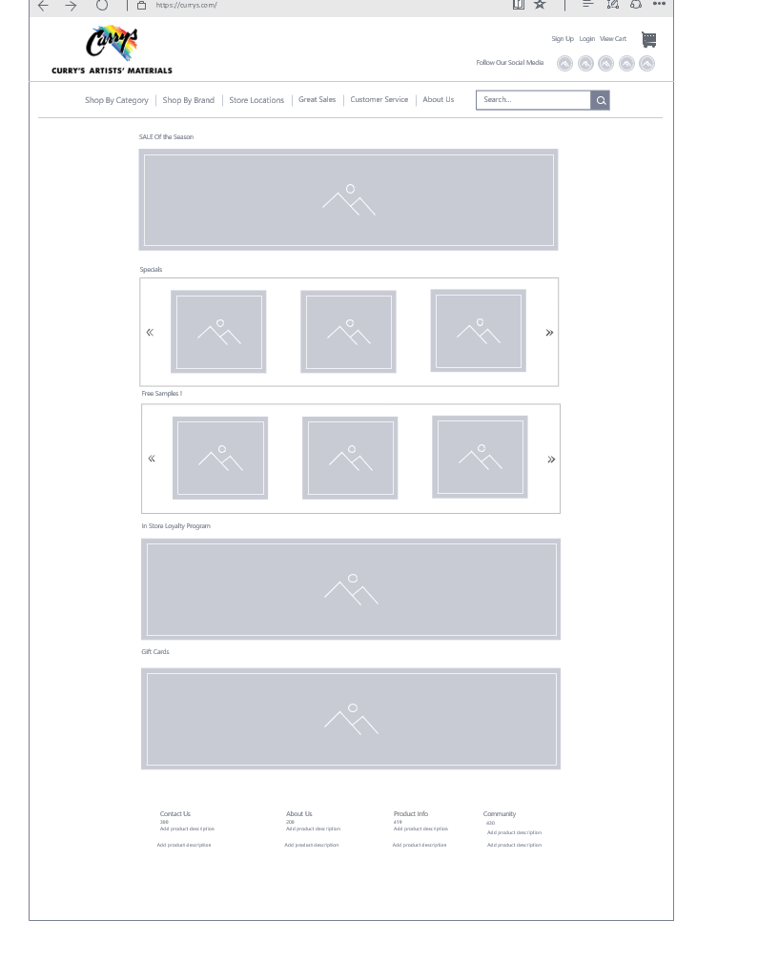

**The next Thing I changed**

I changed the interface for the Navigations. When clicking the Shop by category or brand, it would take you to a page that was ugly and bland, and a waste of a click, because it would send you to a different page, instead, I opted for a way for the user to get through the websites navigation by just using the home page instead of multiple pages. To do that I added it in the navigation. This also eliminated the fact that some products have random images in the specific category section, that made the site feel like it had very bad flow.

**The original version of the pages**

**Categories page**

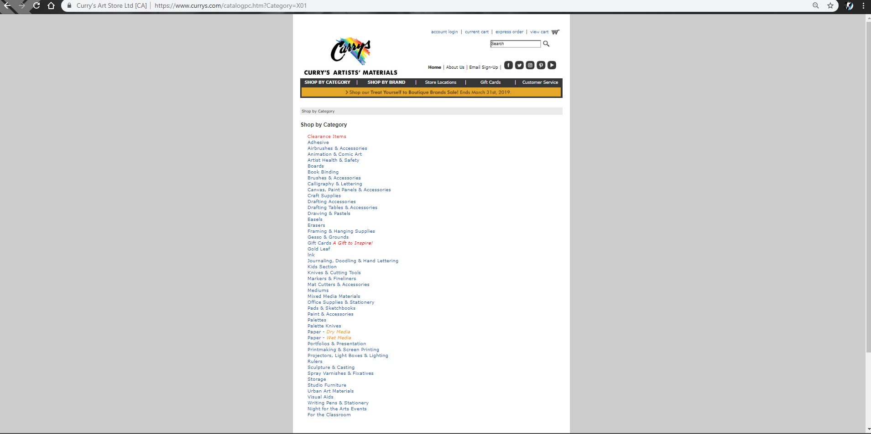

**A specific page for a product**

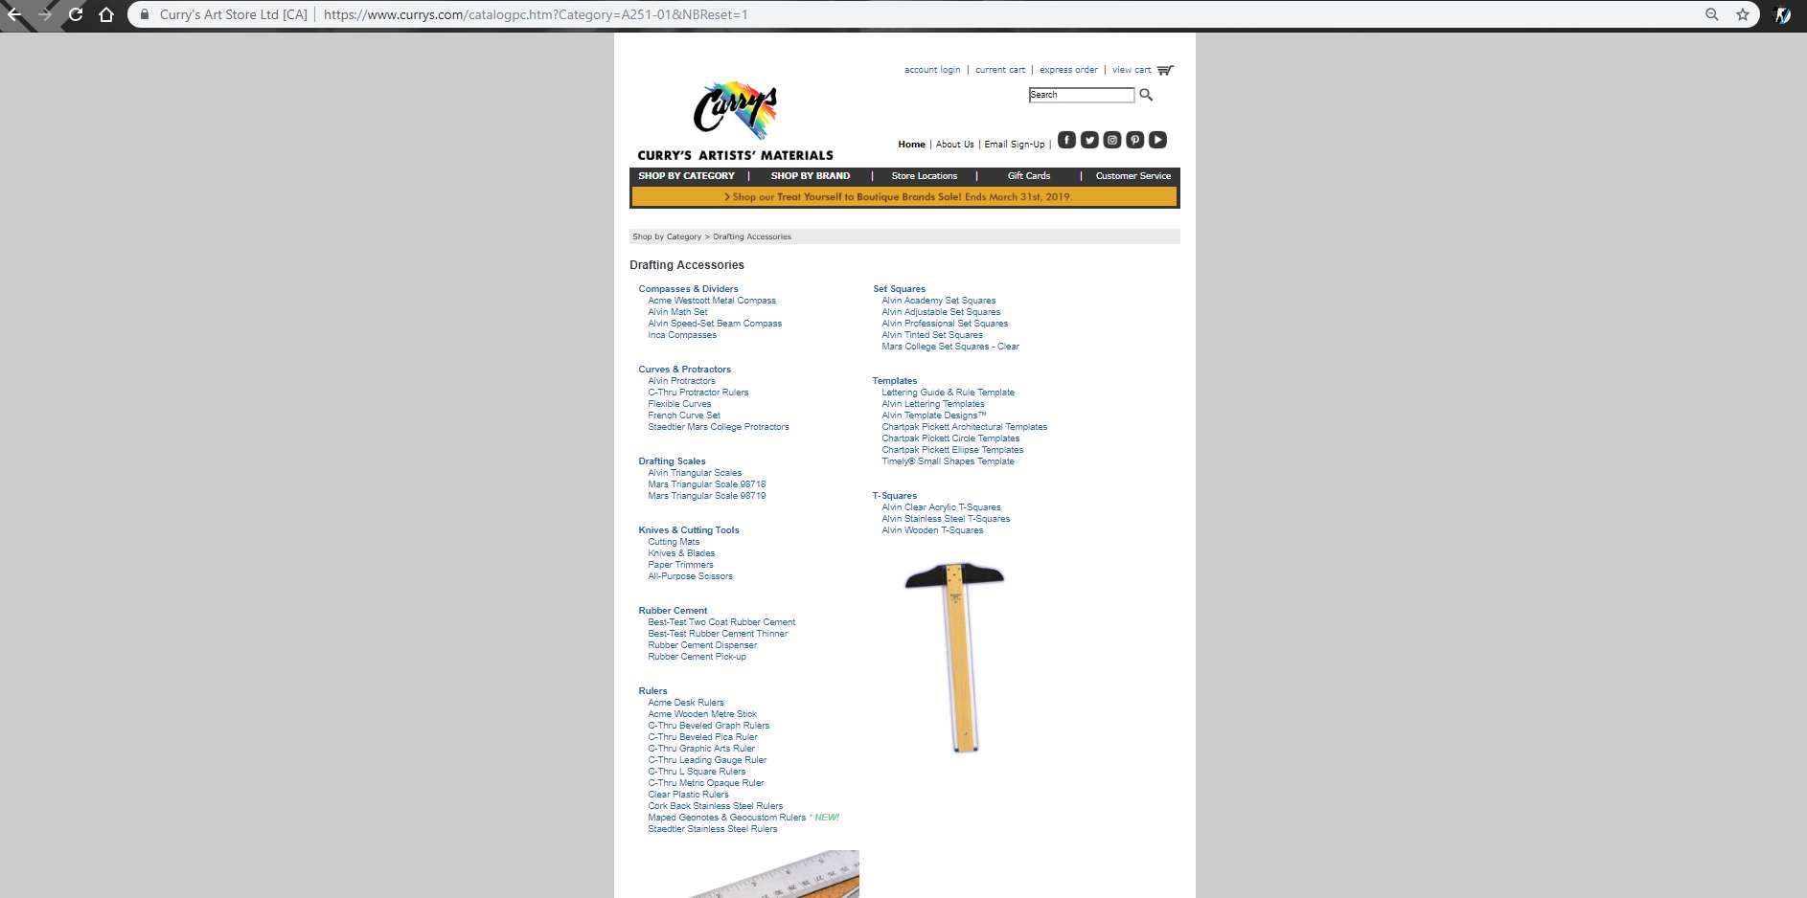

**The Wireframe Version of the Navigation pages**

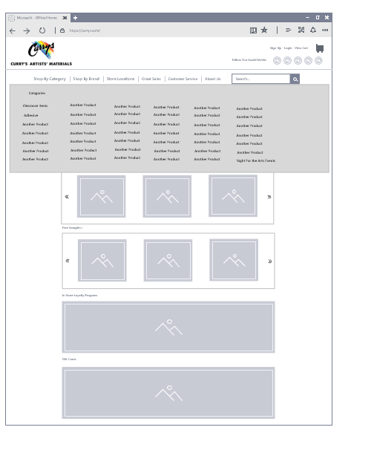

The page when a link is clicked, it would compress the others and make the category you used, and the option to go back to the previous categories

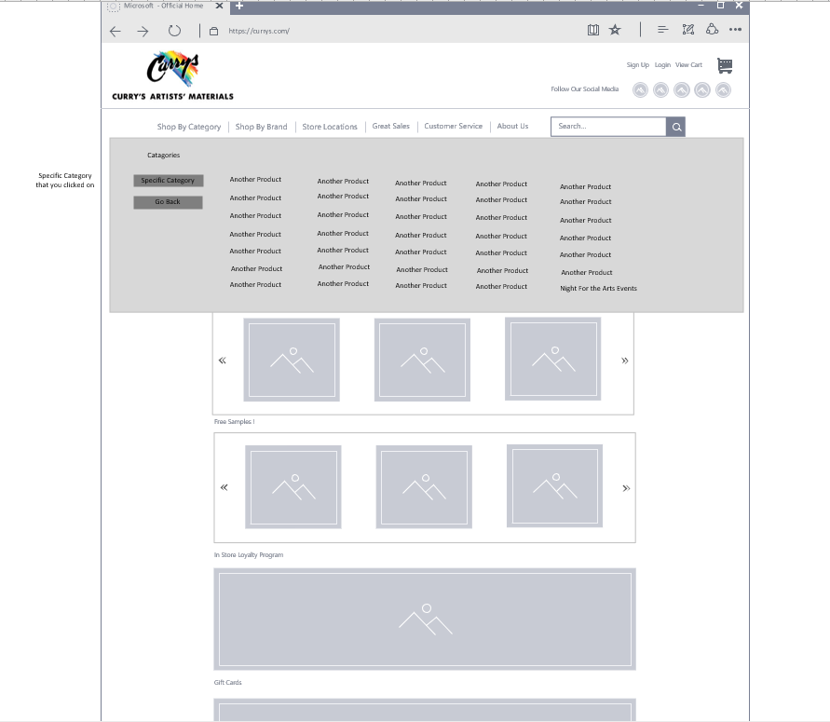

**The next thing I changed was the product layout**

**Original product layout**

Minor changes to the layout of the product, but I changed it a little so that it shows products like it and makes the interface a lot nicer to look at because of how organised the site looks

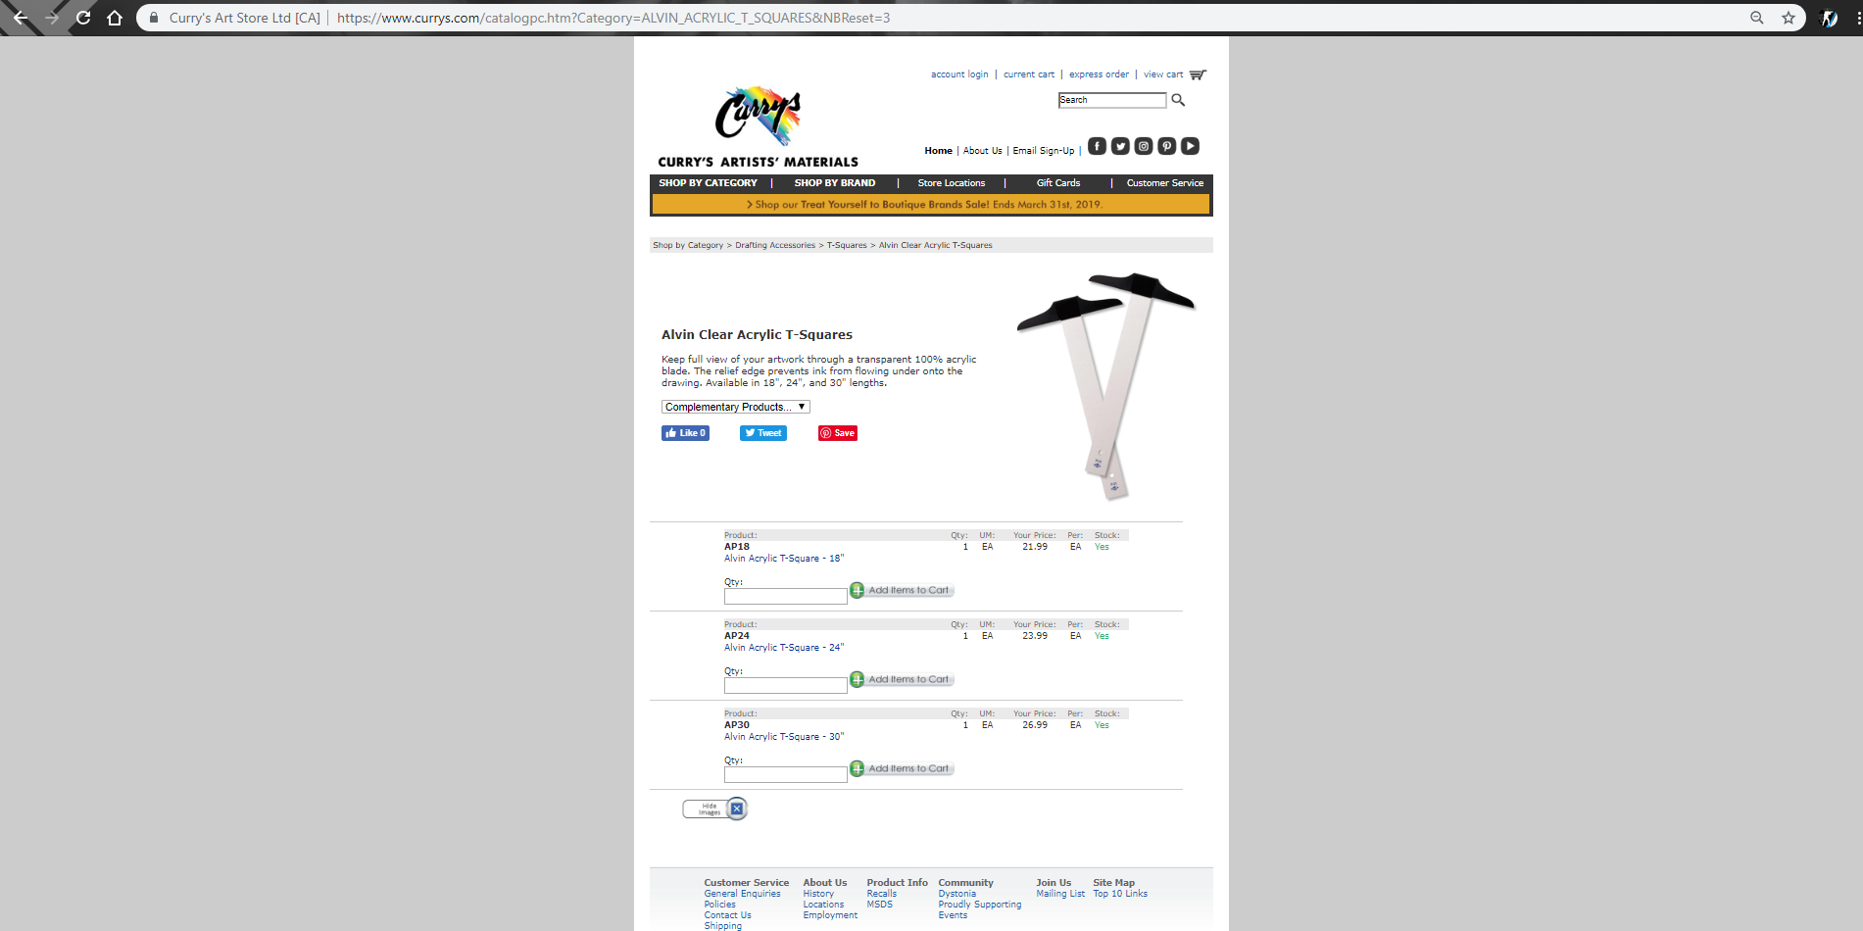

**Wireframes version of the website**

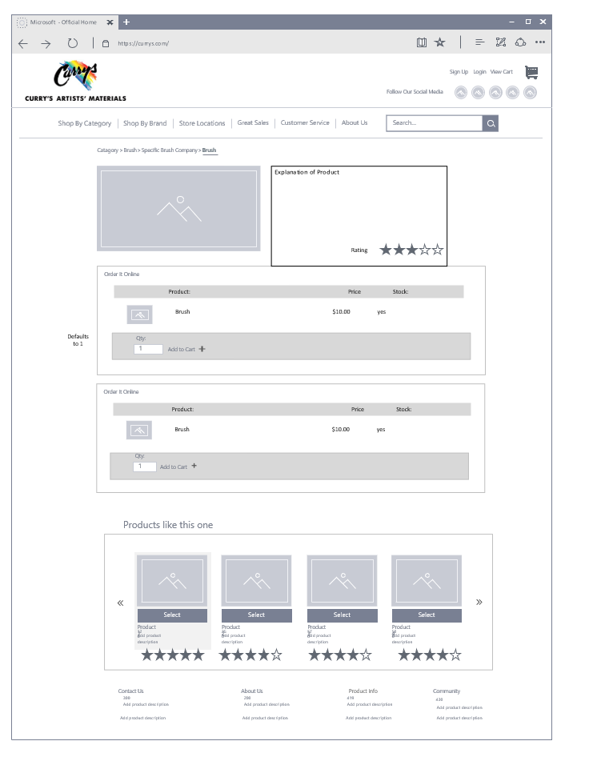

**Wireframe Design for Product Cart and paymentd**

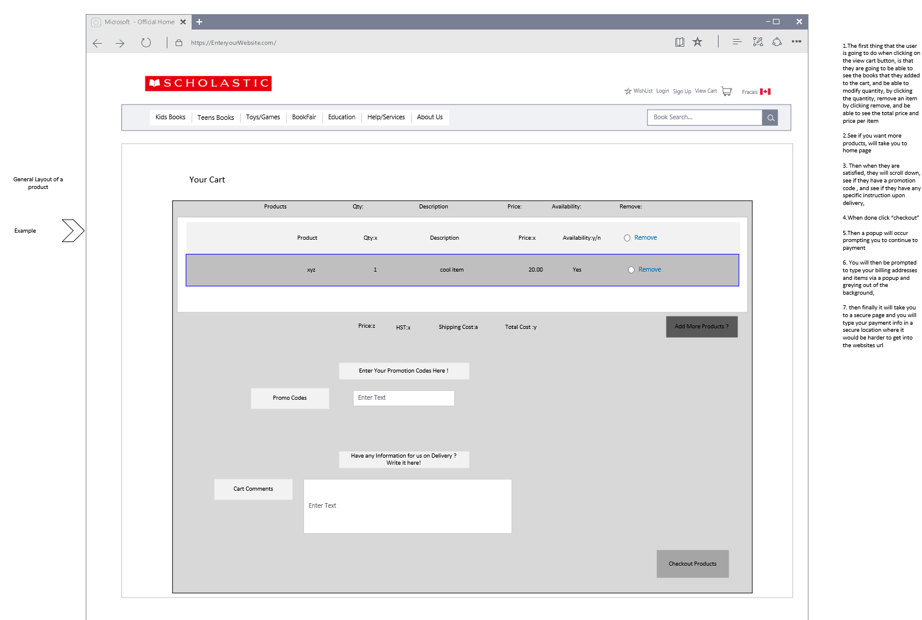

Then you would encounter a pop up when done this page, prompting you to go back and add things or continue to payment

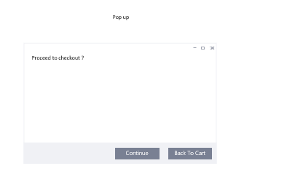

Then there would be another popup, while the rest of the page is grey, where you would type your address, email and that stuff, then you would be directed to the safe page of your car providers website

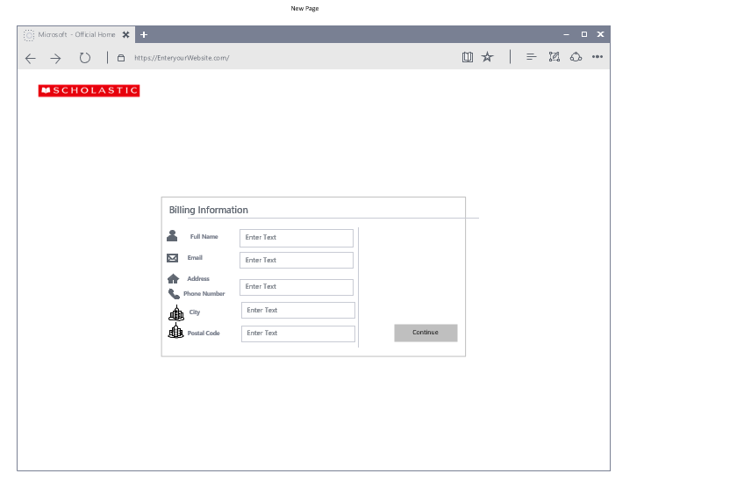

Then it takes you to the card providers website for you to pay

